**C# .NET LABORATORY (18MCA56) PART-B**

Submitted in partial fulfillment of Vth Semester MASTER OF COMPUTER APPLICATIONS

Of

Visvesvaraya Technological University



**MD. MIRAJ ANSARI**

**(1AY18MCA14)**

Under the Guidance of

**Prof. K. Ramakrishna Reddy**



Examiner 1…………….

**Head of Department**

Prof. Manish Kumar Thakur

Examiner 2……………. Department of MCA

Acharya Institute of Technology

Acharya Dr. Sarvepalli Radhakrishna Road,

Soldevanahalli, Bangalore – 560107 [www.acharya.ac.in](http://www.acharya.ac.in/)

**INDEX**

|  |  |  |
| --- | --- | --- |
| **S. NO.** | **TOPIC** | **PAGE NO.** |
| 1. | Develop a suitable window application using C#.NET for  Employee Management System. | 1 |
| 2. | Develop a suitable window application using C#.NET for  Lecturer Allocation System. | 11 |
| 3. | Develop a suitable window application using C#.NET for Vehicle Service Station. | 22 |
| 4. | Develop a web application using C#.NET and ASP.NET for Postal System Management. | 31 |

## C# .Net Lab - Part B

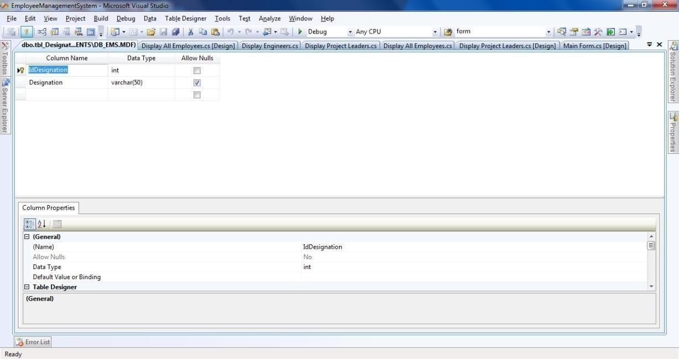

1

**1) Consider the Database db_EMS (Employee Management System) consisting of the following tables :**

**tbl_Designations (IdDesignation: int, Designation: string) tbl_EmployeeDetails(IdEmployee: int, EmployeeName: string, ContactNumber: string, IdDesignation:**

**int, IdReportingTo: int)**

**Develop a suitable window application using C#.NET having following options.**

1. **Enter new Employee details with designation & Reporting Manager.**
2. **Display all the Project Leaders (In a Grid) reporting to selected Project Managers (In a Combo box).**
3. **Display all the Engineers (In a Grid) reporting to selected Project Leader (In a Combo box).**
4. **Display all the Employees (In a Grid) with their reporting Manager (No Value for PM).**

**NOTE: tbl_Designation is a static table containing the following Rows in it.**

|  |  |
| --- | --- |
| **1** | **Project Manager** |
| **2** | **Project Leader** |
| **3** | **Engineer** |

1. **tbl_Designations – Table Design:**

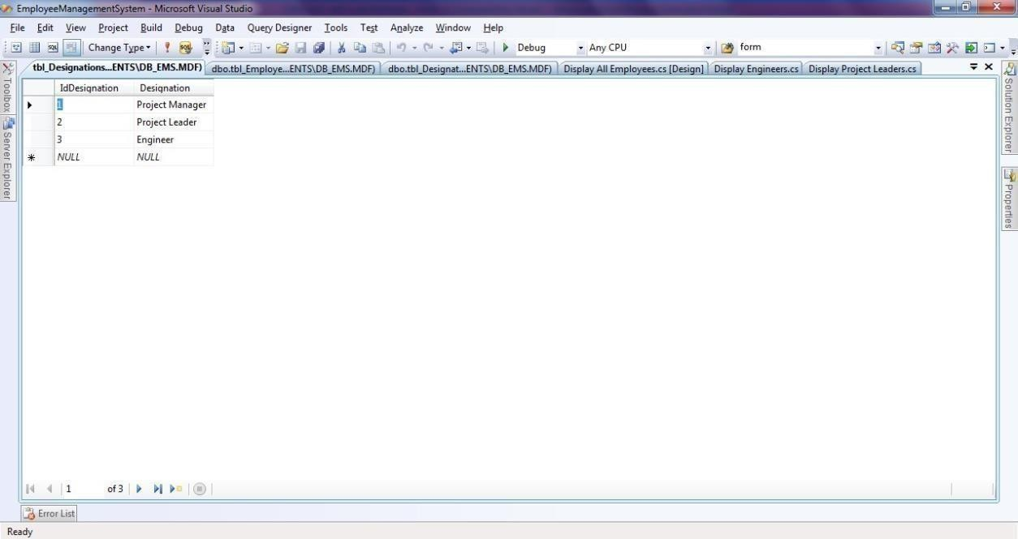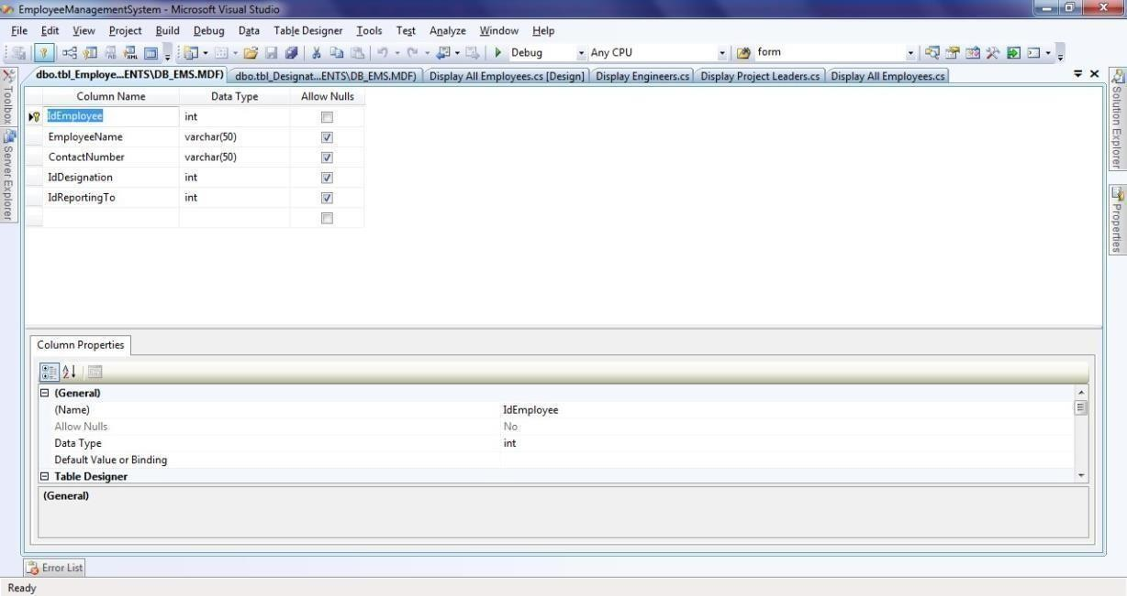

**tbl_Designations – Static Table:**

1. **tbl_EmployeeDetails – Table Design:**

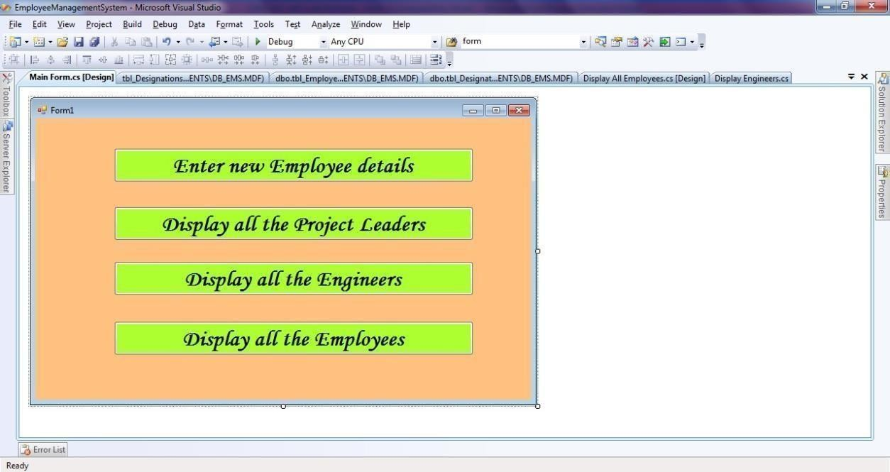

1. **Main Form – Design:**

**Main Form – Code:**

using System; using System.Text;

using System.Windows.Forms;

namespace EmployeeManagementSystem

{

public partial class Form1 : Form

{

public Form1()

{

InitializeComponent();

}

private void button2_Click(object sender, EventArgs e)

{

Display_Project_Leaders obj = new Display_Project_Leaders(); obj.Show();

}

private void button1_Click(object sender, EventArgs e)

{

NewEmployee obj = new NewEmployee(); obj.Show();

}

private void button3_Click(object sender, EventArgs e)

{

Display_Engineers obj=new Display_Engineers(); obj.Show();

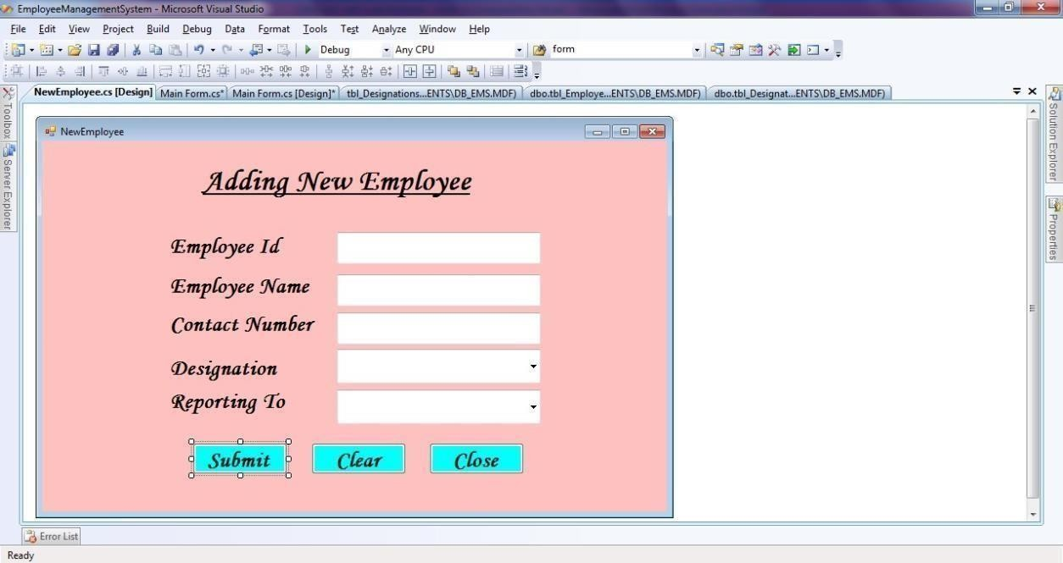

}

private void button4_Click(object sender, EventArgs e)

{

Display_All_Employees obj = new Display_All_Employees(); obj.Show();

}

}

}

# New Employee Form – Design:

**New Employee Form – Code:**

using System;

using System.Windows.Forms; using System.Data.SqlClient;

namespace EmployeeManagementSystem

{

public partial class NewEmployee : Form

{

public NewEmployee()

{

InitializeComponent();

}

private void button1_Click(object sender, EventArgs e)

{

SqlConnection con = new SqlConnection("Data Source=.\\SQLEXPRESS;AttachDbFilename=C:\\Users\\RAJESH\\Documents\\db_EMS.mdf;Inte grated Security=True;Connect Timeout=30;User Instance=True");

con.Open();

int iddesignation = comboBox1.SelectedIndex+1; int idreport=0; if (comboBox2.SelectedValue != null)

idreport =int.Parse( comboBox2.SelectedValue.ToString());

string query = "insert into tbl_EmployeeDetails (IdEmployee,EmployeeName,ContactNumber,IdDesignation,IdReportingTo) values(" + textBox1.Text + ",'" + textBox2.Text + "','" + textBox3.Text + "'," +iddesignation

+ "," + idreport + ")";

SqlCommand cmd = new SqlCommand(query, con); int i = cmd.ExecuteNonQuery();

if (i > 0)

{

Sucessfully");

}

else

{

}

MessageBox.Show("New Emplyee'" + textBox2.Text + "' Added

MessageBox.Show("INSERTION FAILED");

con.Close();

}

private void button2_Click(object sender, EventArgs e)

{

textBox1.Text = ""; textBox2.Text = ""; textBox3.Text = ""; comboBox1.SelectedIndex =-1;

comboBox2.SelectedIndex =-1;

}

private void NewEmployee_Load(object sender, EventArgs e)

{

SqlConnection con = new SqlConnection("Data Source=.\\SQLEXPRESS;AttachDbFilename=C:\\Users\\RAJESH\\Documents\\db_EMS.mdf;Inte grated Security=True;Connect Timeout=30;User Instance=True");

con.Open();

string sqlstr = "select IdDesignationfrom tbl_Designations "; SqlDataAdapter sd DataSet ds = new DataSet();

sda.Fill(ds);

comboBox1.DataSource = ds.Tables[0]; comboBox1.ValueMember = "IdDesignation"; comboBox1.DisplayMember = "IdDesignation";

string sqlstr1 = "select IdEmployee from tbl_EmployeeDetails where IdDesignation=" + comboBox1.SelectedIndex+ " ";

SqlDataAdapter sda1 = new SqlDataAdapter(sqlstr1, con); DataSet ds1 = new DataSet();

sda1.Fill(ds1);

comboBox2.DataSource = ds1.Tables[0];

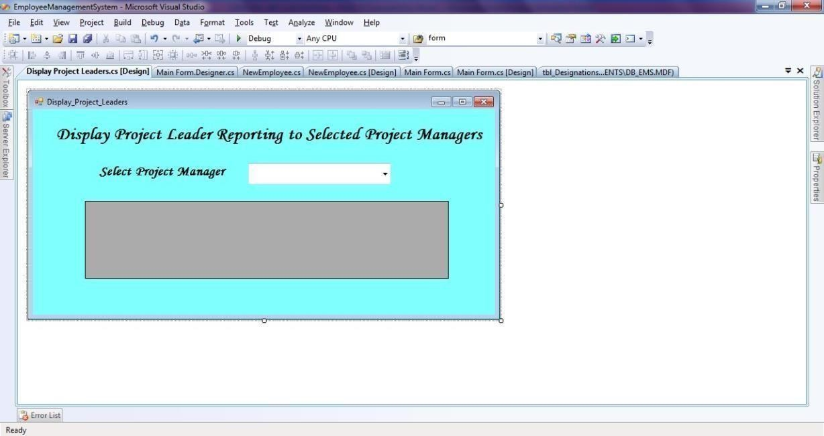

comboBox2.ValueMember = "IdEmployee"; comboBox2.DisplayMember = "IdEmployee";

con.Close();

}

private void comboBox1_SelectionChangeCommitted(object sender, EventArgs e)

{

SqlConnection con = new SqlConnection("Data Source=.\\SQLEXPRESS;AttachDbFilename=C:\\Users\\adminz1\\Documents\\db_EMS.mdf;Int egrated Security=True;Connect Timeout=30;User Instance=True");

con.Open();

string sqlstr1 = "select IdEmployee from tbl_EmployeeDetails where IdDesignation=" + comboBox1.SelectedIndex+ " ";

SqlDataAdapter sda1 = new SqlDataAdapter(sqlstr1, con); DataSet ds1 = new DataSet();

sda1.Fill(ds1);

comboBox2.DataSource = ds1.Tables[0]; comboBox2.ValueMember = "IdEmployee"; comboBox2.DisplayMember = "IdEmployee"; con.Close();

}

private void button3_Click(object sender, EventArgs e)

{

this.Close();

}

}

}

# Display all the Project Leaders Form – Design:

**Display all the Project Leaders Form – Code:**

using System;

using System.Collections.Generic; using System.ComponentModel; using System.Data;

using System.Drawing; using System.Linq; using System.Text;

using System.Windows.Forms; using System.Data.SqlClient;

namespace EmployeeManagementSystem

{

public partial class Display_Project_Leaders : Form

{

public Display_Project_Leaders()

{

InitializeComponent();

}

private void Display_Project_Leaders_Load(object sender, EventArgs e)

{

SqlConnection con = new SqlConnection("Data Source=.\\SQLEXPRESS;AttachDbFilename=C:\\Users\\RAJESH\\Documents\\db_EMS.mdf;Inte grated Security=True;Connect Timeout=30;User Instance=True");

con.Open();

string sqlstr = "select IdEmployee from tbl_EmployeeDetails where IdDesignation=" + 1 + "

";

SqlDataAdapter sda = new SqlDataAdapter(sqlstr, con); DataSet ds = new DataSet();

sda.Fill(ds);

comboBox1.DataSource = ds.Tables[0]; comboBox1.ValueMember = "IdEmployee"; comboBox1.DisplayMember = "IdEmployee";

string sqlstr1 = "select * from tbl_EmployeeDetails where

tbl_EmployeeDetails.IdReportingTo=" + comboBox1.SelectedValue + "";

SqlDataAdapter sda1 = new SqlDataAdapter(sqlstr1, con); DataSet ds1 = new DataSet();

sda1.Fill(ds1);

dataGridView1.DataSource = ds1.Tables[0];

}

private void comboBox1_SelectionChangeCommitted(object sender, EventArgs e)

{

SqlConnection con = new SqlConnection("Data Source=.\\SQLEXPRESS;AttachDbFilename=C:\\Users\\adminz1\\Documents\\db_EMS.mdf;Int egrated Security=True;Connect Timeout=30;User Instance=True");

con.Open();

string sqlstr1 = "select * from tbl_EmployeeDetails where tbl_EmployeeDetails.IdReportingTo=" + comboBox1.SelectedValue +"";

SqlDataAdapter sda1 = new SqlDataAdapter(sqlstr1,con);

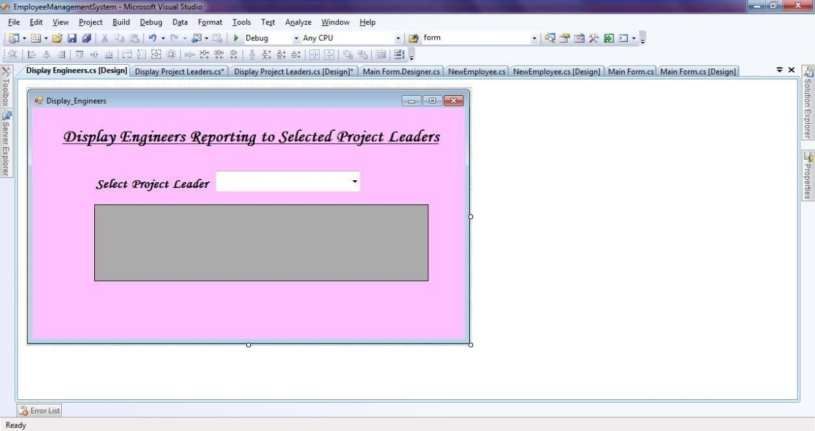

DataSet ds1 = new DataSet(); sda1.Fill(ds1);

dataGridView1.DataSource = ds1.Tables[0]; con.Close();

}

}

}

# Display all the Project Engineers Form – Design:

**Display all the Project Engineers Form – Code:**

using System;

using System.Collections.Generic; using System.ComponentModel; using System.Data;

using System.Drawing; using System.Linq; using System.Text;

using System.Windows.Forms; using System.Data.SqlClient;

namespace EmployeeManagementSystem

{

public partial class Display_Engineers : Form

{

publicDisplay_Engineers()

{

InitializeComponent();

}

private void Display_Engineers_Load(object sender, EventArgs e)

{

SqlConnection con = new SqlConnection("Data Source=.\\SQLEXPRESS;AttachDbFilename=C:\\Users\\RAJESH\\Documents\\db_EMS.mdf;Inte grated Security=True;Connect Timeout=30;User Instance=True");

con.Open();

string sqlstr = "select IdEmployee from tbl_EmployeeDetails where IdDesignation=" + 2 + "

";

SqlDataAdapter sda = new SqlDataAdapter(sqlstr, con); DataSet ds = new DataSet();

sda.Fill(ds);

comboBox1.DataSource = ds.Tables[0]; comboBox1.ValueMember = "IdEmployee"; comboBox1.DisplayMember = "IdEmployee";

string sqlstr1 = "select * from tbl_EmployeeDetails where tbl_EmployeeDetails.IdReportingTo=" + comboBox1.SelectedValue + "";

SqlDataAdapter sda1 = new SqlDataAdapter(sqlstr1, con); DataSet ds1 = new DataSet();

sda1.Fill(ds1);

dataGridView1.DataSource = ds1.Tables[0];

}

private void comboBox1_SelectionChangeCommitted(object sender, EventArgs e)

{

SqlConnection con = new SqlConnection("Data Source=.\\SQLEXPRESS;AttachDbFilename=C:\\Users\\adminz1\\Documents\\db_EMS.mdf;Int egrated Security=True;Connect Timeout=30;User Instance=True");

con.Open();

string sqlstr1 = "select * from tbl_EmployeeDetails where tbl_EmployeeDetails.IdReportingTo=" + comboBox1.SelectedValue + "";

SqlDataAdapter sda1 = new SqlDataAdapter(sqlstr1, con); DataSet ds1 = new DataSet();

sda1.Fill(ds1);

dataGridView1.DataSource = ds1.Tables[0];

}

}

}

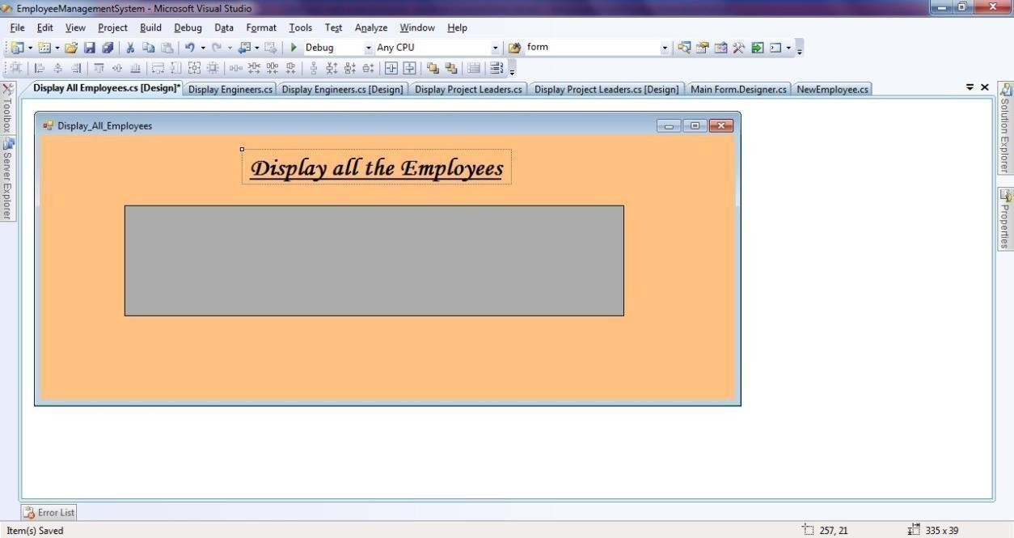

# Display all the Employees Form – Design:

**Display all the Employees Form – Code:**

using System; using System.Text;

using System.Windows.Forms; using System.Data.SqlClient;

namespace EmployeeManagementSystem

{

public partial class Display_All_Employees : Form

{

public Display_All_Employees()

{

InitializeComponent();

}

private void Display_All_Employees_Load(object sender, EventArgs e)

{

SqlConnection con = new SqlConnection("Data Source=.\\SQLEXPRESS;AttachDbFilename=C:\\Users\\RAJESH\\Documents\\db_EMS.mdf;Inte grated Security=True;Connect Timeout=30;User Instance=True");

con.Open();

string sqlstr1 = "select * from tbl_EmployeeDetails"; SqlDataAdapter sda1 = new SqlDataAdapter(sqlstr1, con); DataSet ds1 = new DataSet(); sda1.Fill(ds1);

dataGridView1.DataSource = ds1.Tables[0];

}

}

}

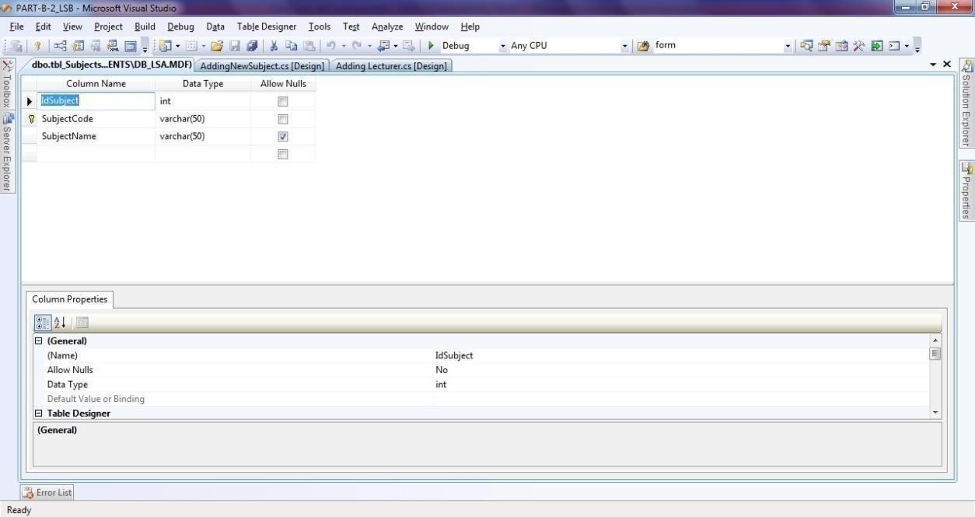

# Consider the Database db_LSA (Lecturer Subject Allocation) consisting of the followingtables: tbl_Subjects(IdSubject: int, SubjectCode: string, SubjectName: string) tbl_Lecturers(IdLecturer: int, LecturerName: string, ContactNumber: string) tbl_LecturerSubjects(IdSubject: int, SubjectCode: string, IdLecturer: int)

**Develop a suitable window application using C#.NET having following options.**

* 1. **Enter new Subject Details.**
  2. **Enter New Lecturer Details.**
  3. **Subject Allocation with Lecturer Name in a Combo box and subjects to be allocated in Grid with checkboxColumn.**
  4. **Display all the subjects allocated (In a Grid) to the selected Lecturer (In a Combo Box).**

1. **tbl_Subjects – Table Design**
2. **tbl_Lectures – Table Design**

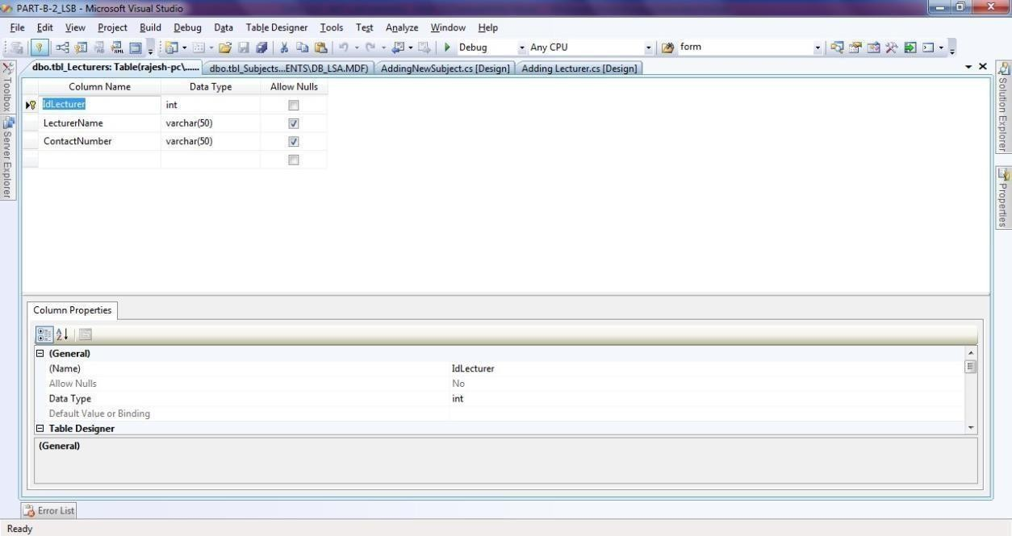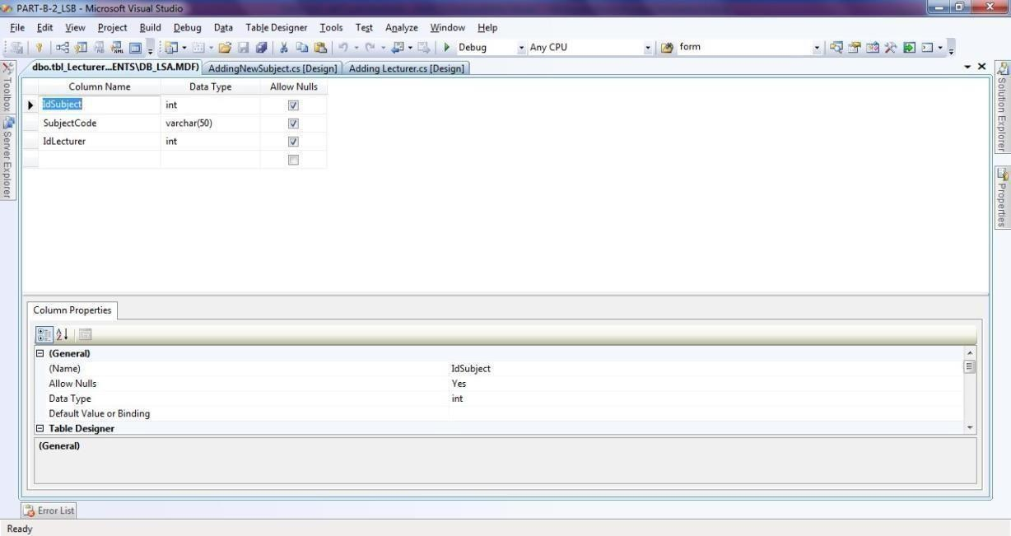

1. **tbl_LecturerSubjects – Table Design**

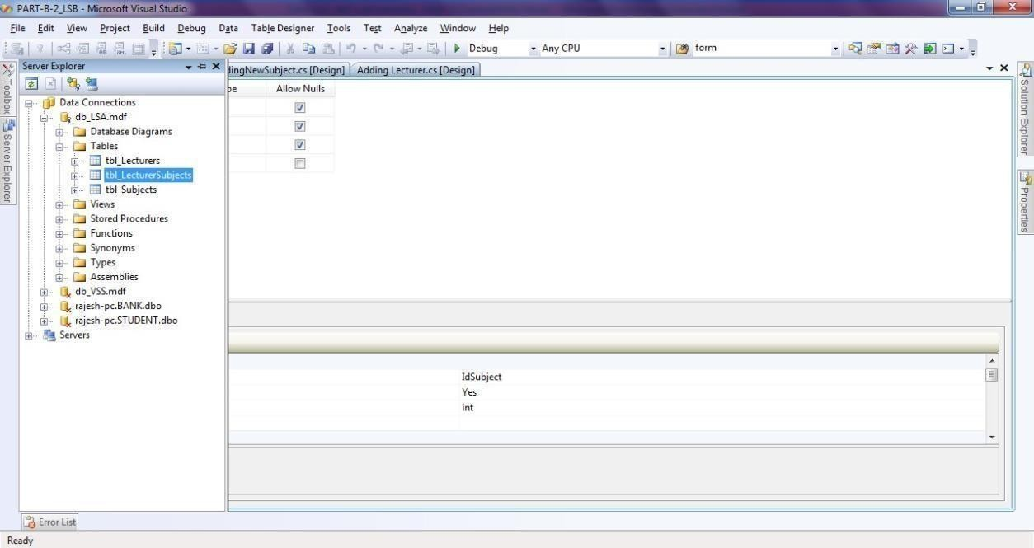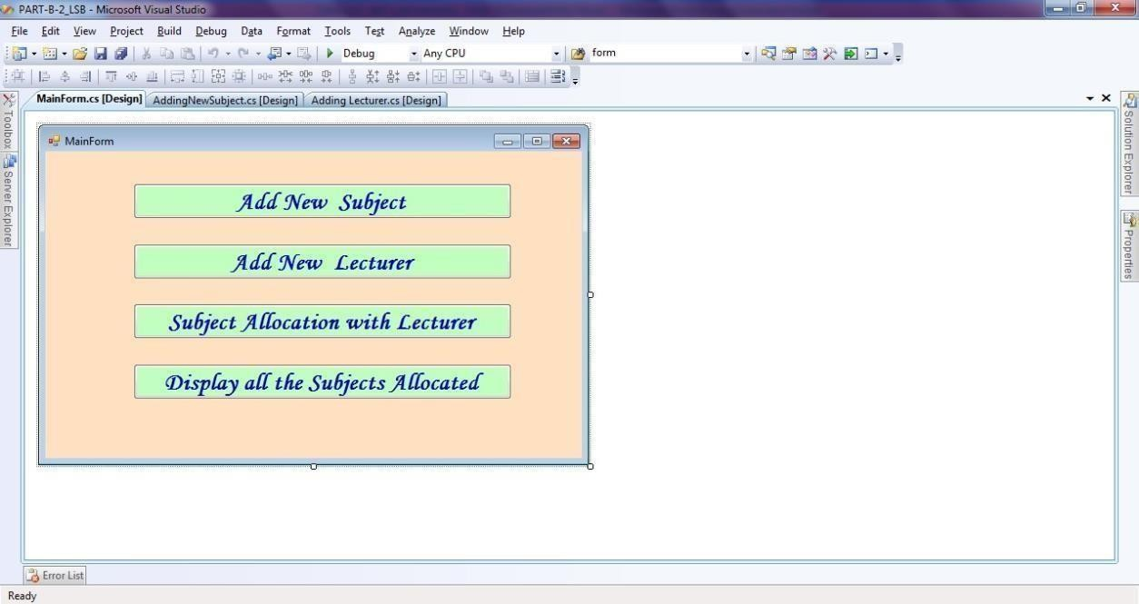

**1) Main Form – Design:**

**Main Form – Code:**

using System;

using System.Collections.Generic; using System.ComponentModel; using System.Data;

using System.Drawing; using System.Linq; using System.Text;

using System.Windows.Forms;

namespace PART_B_2_LSB

{

public partial class MainForm : Form

{

public MainForm()

{

InitializeComponent();

}

private void button1_Click(object sender, EventArgs e)

{

AddingNewSubject obj = new AddingNewSubject(); obj.Show();

}

private void button2_Click(object sender, EventArgs e)

{

Adding_Lecturer obj = new Adding_Lecturer(); obj.Show();

}

private void button3_Click(object sender, EventArgs e)

{

Subject_Allocation obj = new Subject_Allocation(); obj.Show();

}

private void button4_Click(object sender, EventArgs e)

{

Display_All_Subjects_Alloted_to_a_Faculty obj = new Display_All_Subjects_Alloted_to_a_Faculty();

obj.Show();

}

}

}

**C# .Net Lab - Part B 2) Adding New Subject**

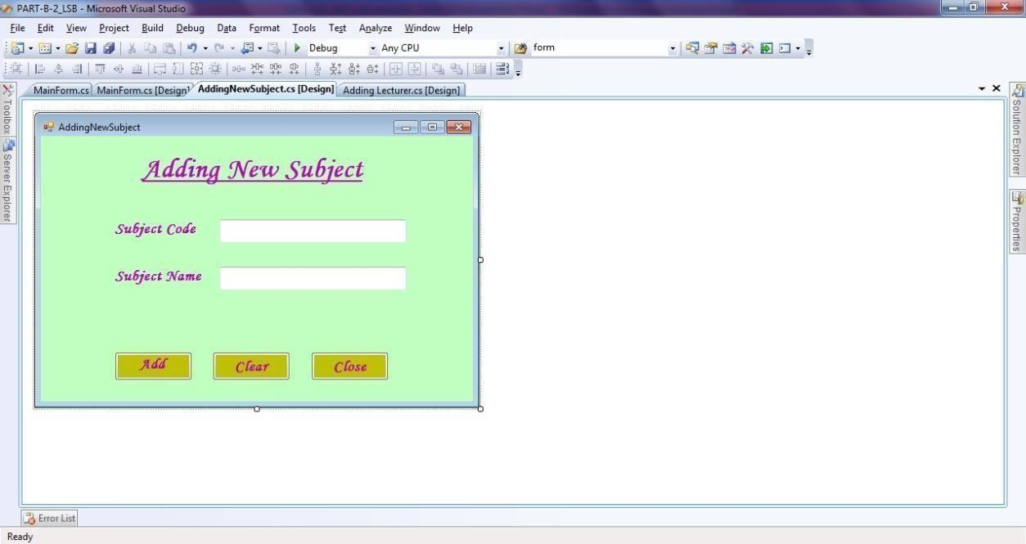

# Form – Design:

**Adding New Subject Form – Code:**

using System;

using System.Collections.Generic; using System.ComponentModel; using System.Data;

using System.Drawing; using System.Linq; using System.Text;

using System.Windows.Forms; using System.Data.SqlClient;

namespace PART_B_2_LSB

{

public partial class AddingNewSubject : Form

{

public AddingNewSubject()

{

InitializeComponent();

}

private void button1_Click(object sender, EventArgs e)

{

SqlConnection con = new SqlConnection("Data Source=.\\SQLEXPRESS;AttachDbFilename=C:\\Users\\RAJESH\\Documents\\db_LSA.mdf;Inte grated Security=True;Connect Timeout=30;User Instance=True");

con.Open();

string query = "insert into tbl_Subjects (SubjectCode,SubjectName) values ('" + textBox2.Text

+ "','" + textBox3.Text + "')";

SqlCommand cmd = new SqlCommand(query, con); int j = cmd.ExecuteNonQuery();

Sucessfully");

if (j > 0)

MessageBox.Show("New Subject '" + textBox3.Text + "' Added

else

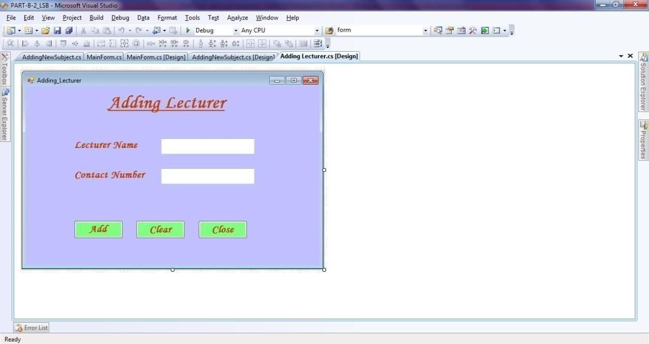

MessageBox.Show("Insertion Failed");

con.Close();

}

private void button2_Click(object sender, EventArgs e)

{

textBox2.Text = ""; textBox3.Text = "";

}

private void button3_Click(object sender, EventArgs e)

{

this.Close();

}

}

}

# Adding Faculty Form – Design:

**Adding Faculty Form – Code:**

using System;

using System.Collections.Generic; using System.ComponentModel; using System.Data;

using System.Drawing; using System.Linq; using System.Text;

using System.Windows.Forms; using System.Data.SqlClient;

namespace PART_B_2_LSB

{

public partial class Adding_Lecturer : Form

{

public Adding_Lecturer()

{

InitializeComponent();

}

private void button1_Click(object sender, EventArgs e)

{

SqlConnection con = new SqlConnection("Data Source=.\\SQLEXPRESS;AttachDbFilename=C:\\Users\\RAJESH\\Documents\\db_LSA.mdf;Inte grated Security=True;Connect Timeout=30;User Instance=True");

con.Open();

string query = "insert into tbl_Lecturers(LecturerName,ContactNumber) values ('" + textBox2.Text + "','" + textBox3.Text + "')";

SqlCommand cmd = new SqlCommand(query, con); int j = cmd.ExecuteNonQuery();

if (j > 0)

MessageBox.Show("New Lecturer '" + textBox2.Text + "' Added

Sucessfully");

else

MessageBox.Show("Insertion Failed");

con.Close();

}

private void button2_Click(object sender, EventArgs e)

{

textBox2.Text = ""; textBox3.Text = "";

}

private void button3_Click(object sender, EventArgs e)

{

this.Close();

}

}

}

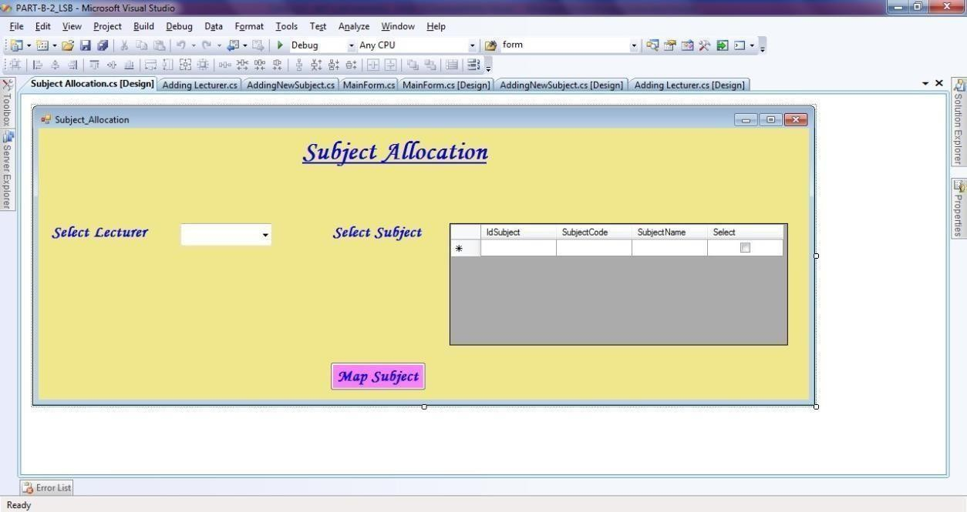

# Subject Mapping Form – Design:

**Subject Mapping Form – Code:**

using System;

using System.Collections.Generic; using System.ComponentModel; using System.Data;

using System.Drawing; using System.Linq; using System.Text;

using System.Windows.Forms; using System.Data.SqlClient;

namespace PART_B_2_LSB

{

public partial class Subject_Allocation : Form

{

public Subject_Allocation()

{

InitializeComponent();

}

private void Subject_Allocation_Load(object sender, EventArgs e)

{

SqlConnection con = new SqlConnection("Data Source=.\\SQLEXPRESS;AttachDbFilename=C:\\Users\\RAJESH\\Documents\\db_LSA.mdf;Inte grated Security=True;Connect Timeout=30;User Instance=True");

con.Open();

string query = "select LecturerName from tbl_Lecturers"; SqlDataAdapter sda

= new SqlDataAdapter(query, con); DataTable dt = new DataTable(); sda.Fill(dt);

comboBox1.DataSource = dt; comboBox1.DisplayMember = "LecturerName"; comboBox1.ValueMember = "LecturerName";

string query1 = "select * from tbl_Subjects"; SqlDataAdapter sda1 = new SqlDataAdapter(query1, con); DataTable dt1 = new DataTable(); sda1.Fill(dt1); dataGridView1.DataSource

= dt1; con.Close();

}

private void button1_Click(object sender, EventArgs e)

{

foreach (DataGridViewRow row in dataGridView1.Rows)

{

bool isSelected=Convert.ToBoolean(row.Cells["Select"].Value); if (isSelected)

{

SqlConnection con = new SqlConnection("Data Source=.\\SQLEXPRESS;AttachDbFilename=C:\\Users\\RAJESH\\Documents\\db_LSA.mdf;Inte grated Security=True;Connect Timeout=30;User Instance=True");

con.Open();

string query = "select IdLecturer from tbl_Lecturers where LecturerName='"+comboBox1.SelectedValue+"'";

SqlDataAdapter sda=new SqlDataAdapter (query,con); DataTable dt = new DataTable();

sda.Fill(dt);

int lectr_id = int.Parse(dt.Rows[0][0].ToString()); int sub_id = int.Parse(row.Cells[1].Value.ToString()); string sub_code = row.Cells[2].Value.ToString();

string query1 = "insert into tbl_LecturerSubjects(IdSubject,SubjectCode,IdLecturer) values (" + sub_id + ",'" + sub_code + "'," + lectr_id + ")";

SqlCommand cmd = new SqlCommand(query1, con); int j = cmd.ExecuteNonQuery();

if (j > 0)

MessageBox.Show("Subject Mapped Sucessfully");

else

MessageBox.Show("Maping Failed");

con.Close();

}

}

}

}

}

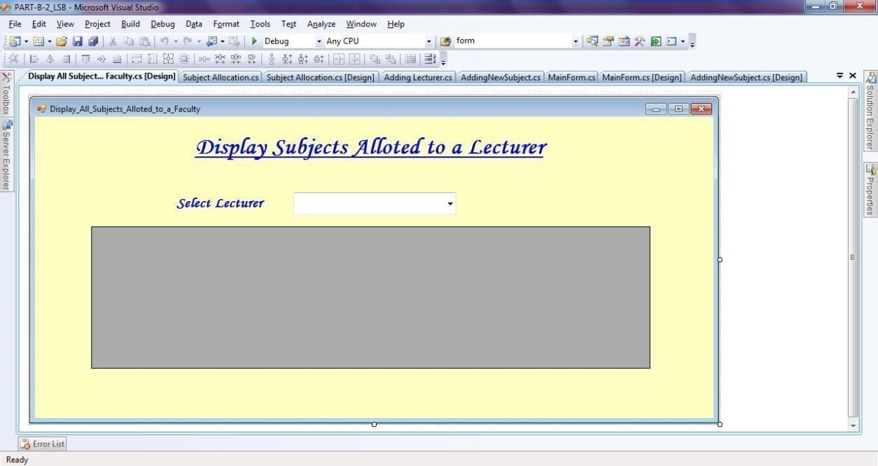

# Display Mapped Subject Alloted to Faculty Form – Design:

**Display Mapped Subject Alloted to Faculty Form – Code:**

using System; usingSystem.Collections.Generic; using System.ComponentModel; using System.Data;

using System.Drawing; using System.Linq; using System.Text;

using System.Windows.Forms; using System.Data.SqlClient;

namespace PART_B_2_LSB

{

public partial class Display_All_Subjects_Alloted_to_a_Faculty : Form

{

public Display_All_Subjects_Alloted_to_a_Faculty()

{

InitializeComponent();

}

private void Display_All_Subjects_Alloted_to_a_Faculty_Load(object sender, EventArgs e)

{

SqlConnection con = new SqlConnection("Data Source=.\\SQLEXPRESS;AttachDbFilename=C:\\Users\\RAJESH\\Documents\\db_LSA.mdf;Inte grated Security=True;Connect Timeout=30;User Instance=True");

con.Open();

string query = "select LecturerName from tbl_Lecturers"; SqlDataAdapter sda

= new SqlDataAdapter(query, con); DataTable dt = new DataTable();

sda.Fill(dt); comboBox1.DataSource = dt;

comboBox1.DisplayMember = "LecturerName"; comboBox1.ValueMember = "LecturerName";

string query1 = "select distinct IdLecturer from tbl_Lecturers where LecturerName='" + comboBox1.SelectedValue + "'";

SqlDataAdapter sda1 = new SqlDataAdapter(query1, con); DataTable dt1 = new DataTable();

sda1.Fill(dt1);

int lectid = int.Parse(dt1.Rows[0][0].ToString());

string query2 = "select distinct * from tbl_LecturerSubjects where IdLecturer= "+lectid +" "; SqlDataAdapter sda2 = new SqlDataAdapter(query2, con); DataTable dt2 =

new DataTable();

sda2.Fill(dt2); dataGridView1.DataSource

= dt2; con.Close();

}

private void comboBox1_SelectionChangeCommitted(object sender, EventArgs e)

{

SqlConnection con = new SqlConnection("Data Source=.\\SQLEXPRESS;AttachDbFilename=C:\\Users\\RAJESH\\Documents\\db_LSA.mdf;Inte grated Security=True;Connect Timeout=30;User Instance=True");

con.Open();

string query1 = "select distinct IdLecturer from tbl_Lecturers where LecturerName='" + comboBox1.SelectedValue + "'";

SqlDataAdapter sda1 = new SqlDataAdapter(query1, con); DataTable dt1 = new DataTable();

sda1.Fill(dt1);

int lectid = int.Parse(dt1.Rows[0][0].ToString());

string query2 = "select distinct * from tbl_LecturerSubjects where IdLecturer= " + lectid + " "; SqlDataAdapter sda2 = new SqlDataAdapter(query2, con); DataTable dt2 =

new DataTable();

sda2.Fill(dt2); dataGridView1.DataSource

= dt2; con.Close();

}

}

}

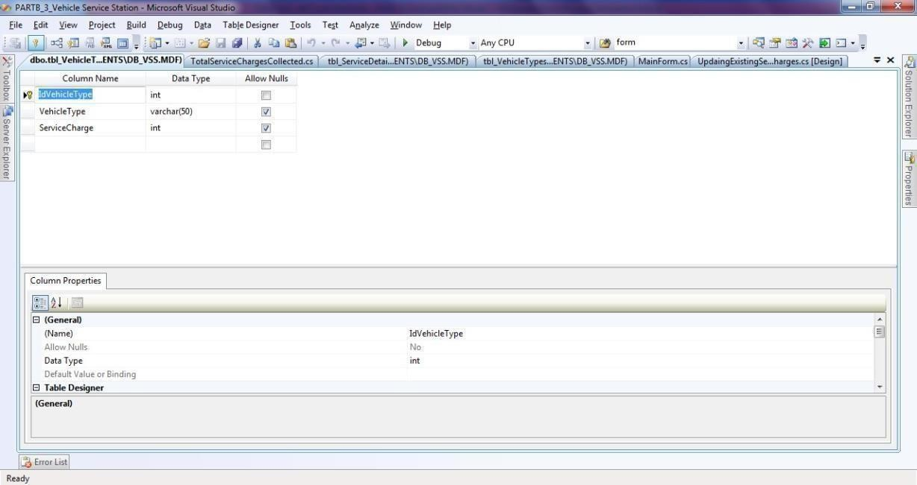

# Consider the database db_VSS (Vehicle Service Station) consisting of the followingtables: tbl_VehicleTypes(IdVehicleType: int, VehicleType: string, ServiceCharge: int) tbl_ServiceDetails(IdService: int, VehicleNumber: string, ServiceDetails: string, IdVehicleType: int)

**Develop a suitable window application using C#.NET having following options.**

* + 1. **Enter new Service Details for the Selected Vehicle Type (In a Combo Box).**
    2. **Update the Existing Service Charges to Database.**
    3. **Total Service Charges Collected for the Selected Vehicle (In a Combo box) with totalamount displayed in a text box.**

**NOTE: tbl_VehicleType is a static table containing the following Rows in it.**

|  |  |  |
| --- | --- | --- |
| **1** | **Two Wheeler** | **500** |
| **2** | **Four Wheeler** | **1000** |
| **2** | **Three Wheeler** | **700** |

1. **tbl_VehicleTypes – Table:**

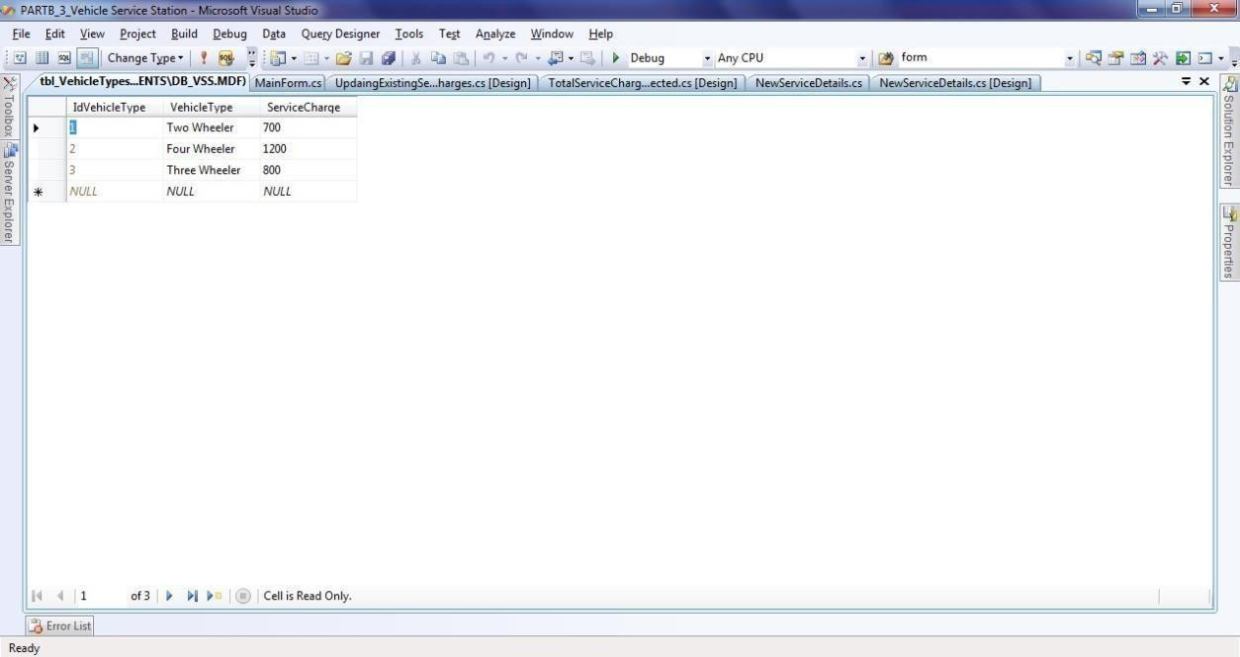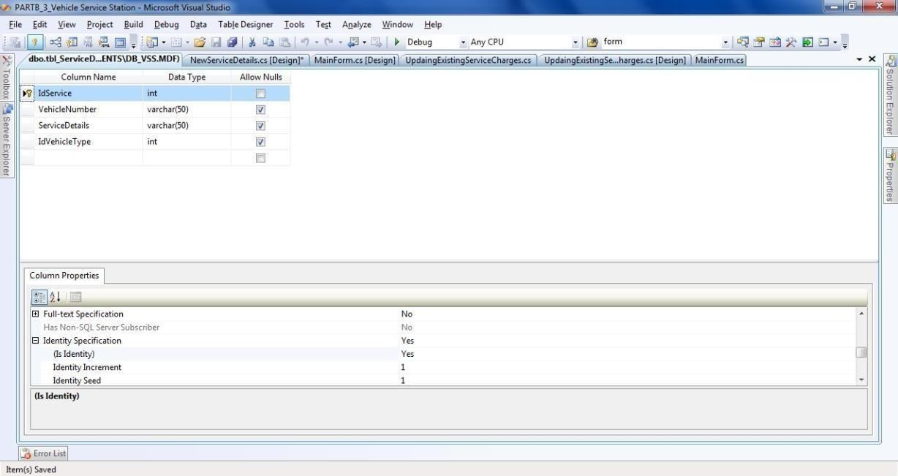

1. **tbl_ServiceDetails – Table:**

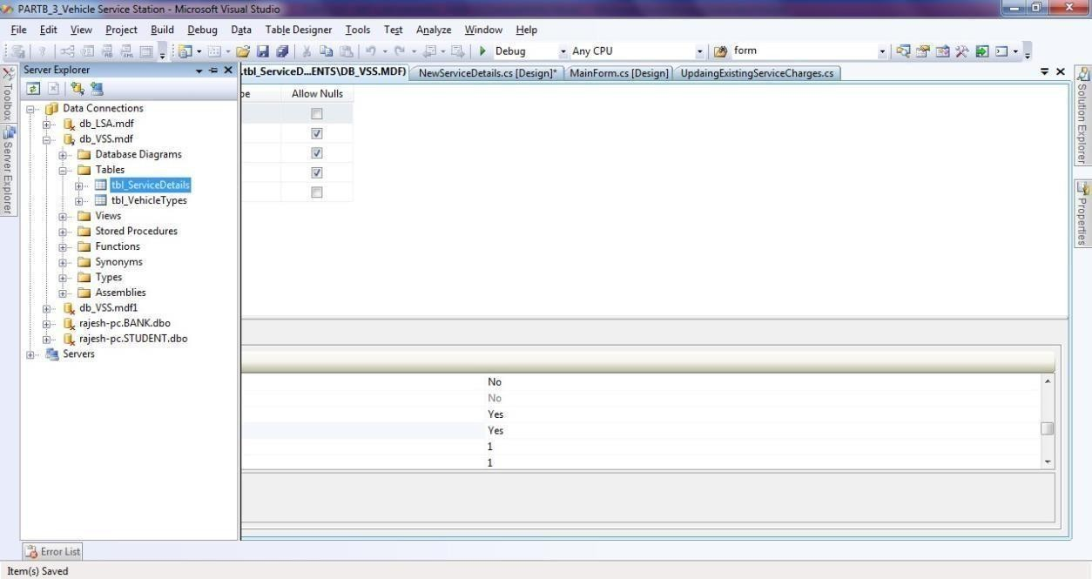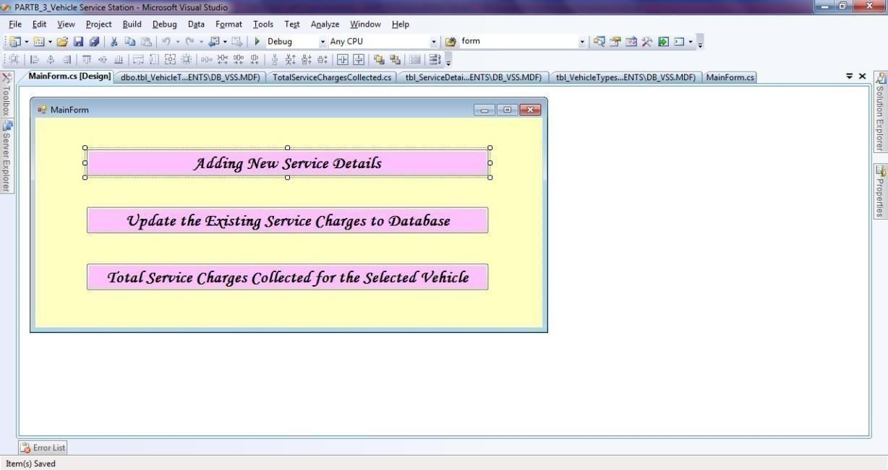

* 1. **MainForm – Design:**

**MainForm – Code:**

using System;

using System.Collections.Generic; using System.ComponentModel; using System.Data;

using System.Drawing; using System.Linq; using System.Text;

using System.Windows.Forms;

namespace PARTB_3_Vehicle_Service_Station

{

public partial class MainForm : Form

{

public MainForm()

{

InitializeComponent();

}

private void button1_Click(object sender, EventArgs e)

{

NewServiceDetails obj = new NewServiceDetails(); obj.Show();

}

private void button3_Click(object sender, EventArgs e)

{

TotalServiceChargesCollected obj = new TotalServiceChargesCollected(); obj.Show();

}

private void button2_Click(object sender, EventArgs e)

{

UpdaingExistingServiceCharges obj = new UpdaingExistingServiceCharges();

obj.Show();

}

}

}

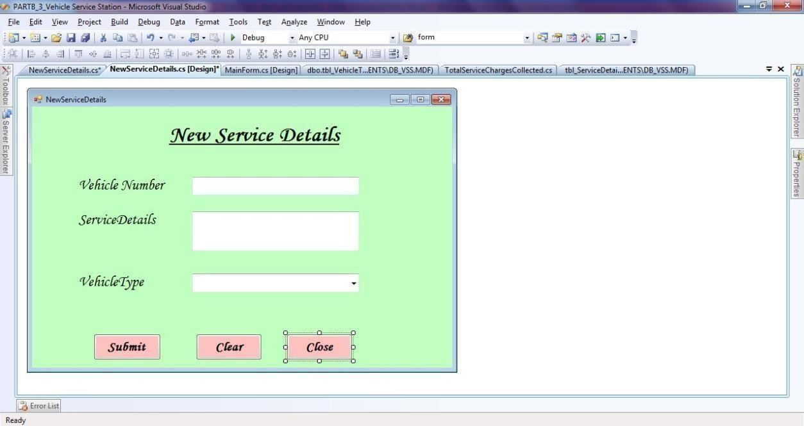

# New Service Form – Design:

**New Service Form – Code:**

using System;

using System.Collections.Generic; using System.ComponentModel; using System.Data;

using System.Drawing; using System.Linq; using System.Text;

using System.Windows.Forms; using System.Data.SqlClient;

namespace PARTB_3_Vehicle_Service_Station

{

public partial class NewServiceDetails : Form

{

publicNewServiceDetails()

{

InitializeComponent();

}

private void button1_Click(object sender, EventArgs e)

{

SqlConnection con = new SqlConnection("Data Source=.\\SQLEXPRESS;AttachDbFilename=C:\\Users\\RAJESH\\Documents\\db_VSS.mdf;Inte grated Security=True;Connect Timeout=30;User Instance=True");

con.Open();

int idvechtype = comboBox1.SelectedIndex + 1;

string query = "insert intotbl_ServiceDetails (VehicleNumber,ServiceDetails,IdVehicleType) values ('" + textBox2.Text + "','" + textBox3.Text + "',"+idvechtype+")";

SqlCommand cmd = new SqlCommand(query, con); int j = cmd.ExecuteNonQuery();

if (j > 0)

MessageBox.Show("Service Done for '" + textBox2.Text + "'

Sucessfully");

else

MessageBox.Show("Insertion Failed");

con.Close();

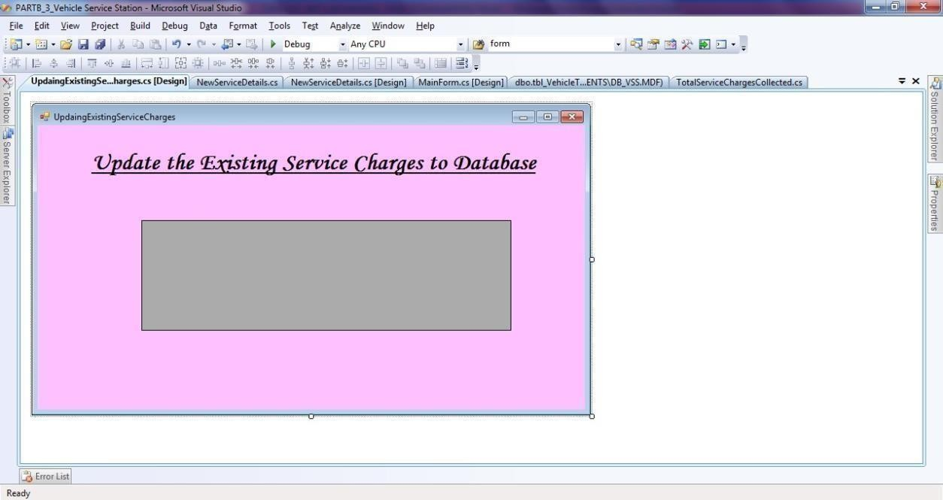

}

private void button2_Click(object sender, EventArgs e)

{

textBox2.Text = ""; textBox3.Text = ""; comboBox1.SelectedIndex= -1;

}

private void button3_Click(object sender, EventArgs e)

{

this.Close();

}

}

}

# Update Service Charge Form – Design:

**Update Service Charge Form – Code:**

using System;

using System.Collections.Generic; using System.ComponentModel;

using System.Data; using System.Drawing; using System.Linq; using System.Text;

using System.Windows.Forms; using System.Data.SqlClient;

namespace PARTB_3_Vehicle_Service_Station

{

public partial class UpdaingExistingServiceCharges : Form

{

public UpdaingExistingServiceCharges()

{

InitializeComponent();

}

private void UpdaingExistingServiceCharges_Load(object sender, EventArgs e)

{

SqlConnection con = new SqlConnection("Data Source=.\\SQLEXPRESS;AttachDbFilename=C:\\Users\\RAJESH\\Documents\\db_VSS.mdf;Inte grated Security=True;Connect Timeout=30;User Instance=True");

con.Open();

string query = "select * from tbl_VehicleTypes"; SqlDataAdapter sda = new SqlDataAdapter(query, con); DataTable dt = new DataTable(); sda.Fill(dt); dataGridView1.DataSource

= dt;

dataGridView1.Columns[0].ReadOnly = true; dataGridView1.Columns[1].ReadOnly = true; con.Close();

}

private void dataGridView1_CellValueChanged(object sender, DataGridViewCellEventArgs e)

{

SqlConnection con = new SqlConnection("Data Source=.\\SQLEXPRESS;AttachDbFilename=C:\\Users\\RAJESH\\Documents\\db_VSS.mdf;Inte grated Security=True;Connect Timeout=30;User Instance=True");

con.Open(); DialogResult result;

result = MessageBox.Show("Are You sure want to update?", "Conformation", MessageBoxButtons.YesNo);

if (result == System.Windows.Forms.DialogResult.Yes)

{

// for (int i = 0; i < dataGridView1.Rows.Count; i++)

SqlCommand command = new SqlCommand("UPDATE tbl_VehicleTypes SET ServiceCharge = " + dataGridView1.SelectedCells[0].Value.ToString() + " Where IdVehicleType = '" +

dataGridView1.CurrentRow.Cells[0].Value.ToString()+ "' ", con); command.ExecuteNonQuery();

MessageBox.Show("Updated Sucessfully");

}

con.Close();

}

}

}

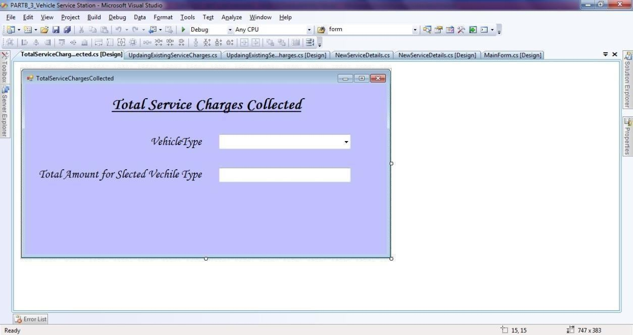

# Total Service Charges Collected Form – Design:

**Toatl Service Charges Collected Form – Code:**

using System;

using System.Collections.Generic; using System.ComponentModel; using System.Data;

using System.Drawing; using System.Linq; using System.Text;

using System.Windows.Forms; using System.Data.SqlClient;

namespace PARTB_3_Vehicle_Service_Station

{

public partial class TotalServiceChargesCollected : Form

{

public TotalServiceChargesCollected()

{

InitializeComponent();

}

private void comboBox1_SelectedValueChanged(object sender, EventArgs e)

{

SqlConnection con = new SqlConnection("Data Source=.\\SQLEXPRESS;AttachDbFilename=C:\\Users\\RAJESH\\Documents\\db_VSS.mdf;Inte grated Security=True;Connect Timeout=30;User Instance=True");

con.Open();

string query = "select IdVehicleType from tbl_ServiceDetails where IdVehicleType=" + (comboBox1.SelectedIndex + 1) + "";

SqlDataAdapter sda = new SqlDataAdapter(query, con); DataTable dt = new DataTable();

sda.Fill(dt);

string query1 = "select ServiceCharge from tbl_VehicleTypes where IdVehicleType=" + (comboBox1.SelectedIndex + 1) + "";

SqlDataAdapter sda1 = new SqlDataAdapter(query1, con); DataTable dt1 = new DataTable();

sda1.Fill(dt1);

int samt=int.Parse(dt1.Rows[0][0].ToString()); int totamt = (dt.Rows.Count) * samt; textBox1.Text = totamt.ToString();

}

}

}

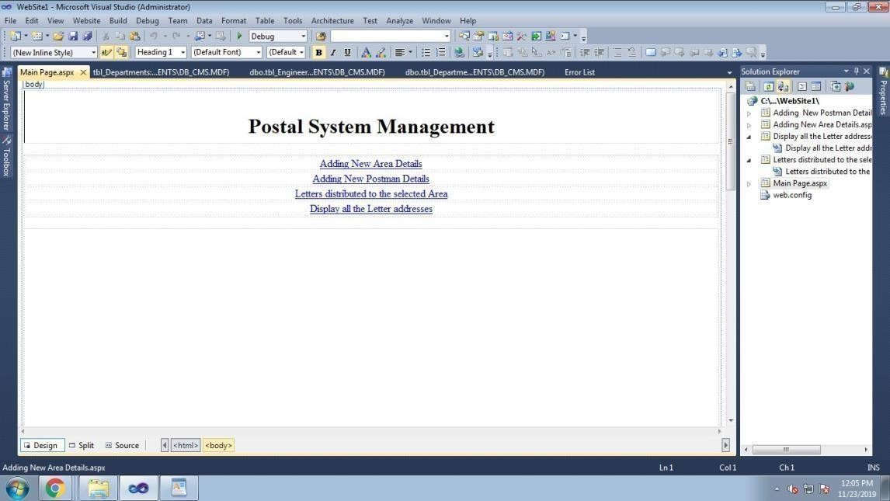

**4) Develop a web application using C#.NET and ASP.NET for the Postal System Management. The master page should contain the hyper links for adding *Area Details*, *Postman details*, *Letter distributions* and *View Letters*.**

# Consider the database db_PSM (Postal System Management) consisting of the following tables: tbl_AreaDetails(IdArea: int, AreaName: string)

**tbl_PostmanDetails(IdPostman: int, PostmanName: string, ContactNumber: string, IdArea: int) tbl_AreaLetters(IdLetter: int, LetterAddress: string, IdArea: int)**

**Develop the suitable content pages for the above created 4 hyper links with the following details:**

1. **Enter New Area Details**
2. **Enter New Postman Details with the Area he/she is in-charge of (display Area in a Combo box)**
3. **Enter all the Letters distributed to the selected Area (display Area in a Combo box)**
4. **Display all the Letter addresses (In a Grid) to be distributed by the selected Postman (In a Combo box**

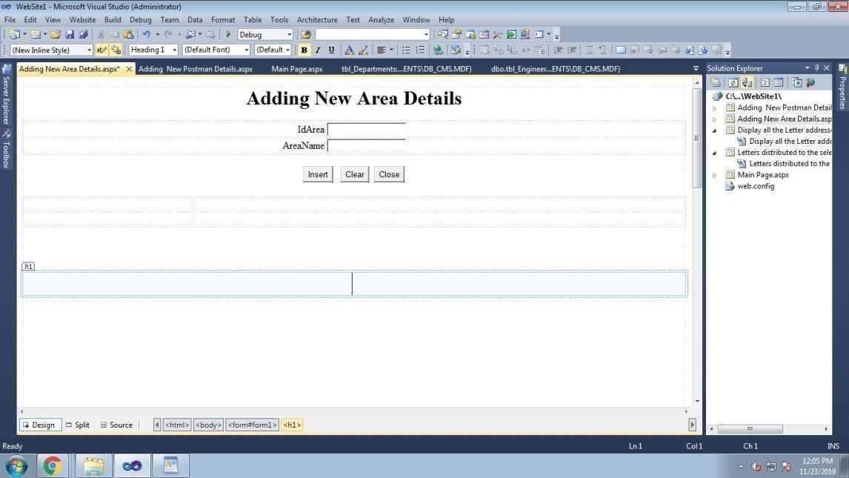

usin g System; usin g

Syste m.C ollections.G en eric; usin g S ystem .Lin q;

usin g S ystem .We b; usin g

Syste m .We b.UI; usin g

Syste m.We b.UI.We bC ontrols;

usin g S ystem.D ata. S qlC lie nt;

public partial class Adding _Ne w _ Area _ D etails : Syste m.We b.UI. Page

{

prote cte d void Pa ge_ Loa d (o bject sender, E ve ntA rgs e)

{

}

prote cte d void B utton1_ C lick(o bject sen der, Eve ntArgs e)

{

S qlC on n e ctio n con = ne w SqlC on ne ctio n("Data

S o urce =.\\ SQ L E X P R E S S ; Atta chD bFile name =C :\\Users\\adm inz 1\\D ocume nts\\d b_ P S M .m df;Inte grate d Se curity=True;C o nnect Time out= 30;User Insta nce =True");

con.O p e n();

strin g qu ery="insert into

tbl_ Area Details(Id Area, Area Name )values("+Text B o x1.Text+",'"+Te xt B ox2.Te xt+"')"; S qlC omm and cmd= ne w S qlC omma n d (que ry,con);

int j =

cmd. Execute N on Q ue ry(); if(j>=1)

Resp onse.Write("<script>a lert('successfuly Insretd');</script>");

else

Resp onse.Write("<script>a lert(' Insretion Faile d');</script>");

con.C lose();}

prote cte d void B utton2_ C lick(o bject sen der, Eve ntArgs e)

{

Text B ox1.T ext = "";

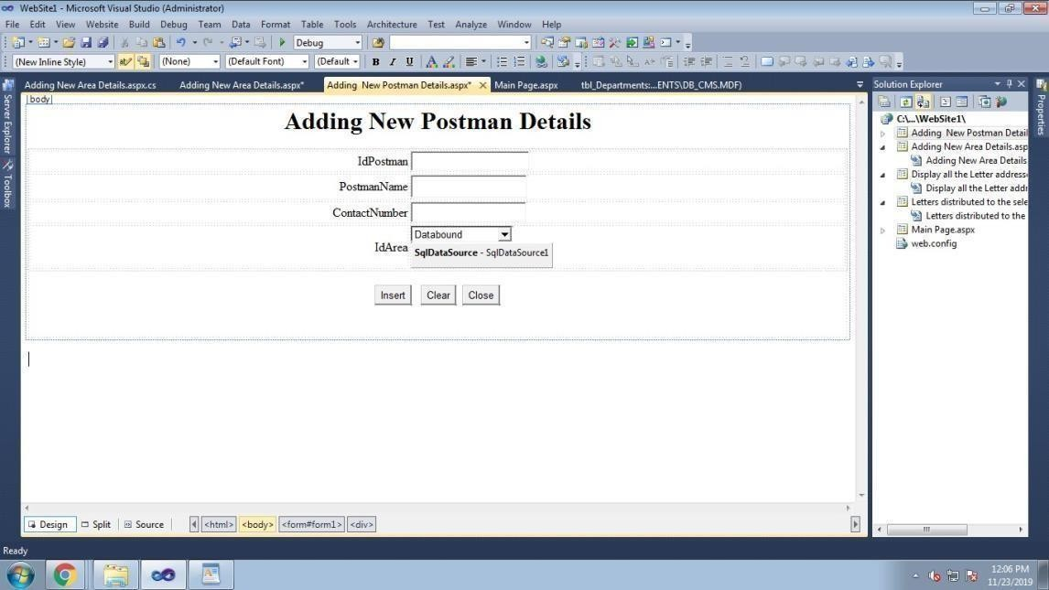

Text B ox2.T ext = "";

}

prote cte d void B utton3_ C lick(o bject sen der, Eve ntArgs e)

{

Resp onse.Write("<script>win dow .close();</script>");

}

}

usin g System; usin g

Syste m.C ollections.G en eric; usin g S ystem .Lin q;

usin g S ystem .We b; usin g

Syste m .We b.UI; usin g

Syste m.We b.UI.We bC ontrols;

usin g S ystem.D ata. S qlC lie nt;

public partial class Adding Ne w_ Postma n _ Details : S yste m.We b.UI. Pa ge

{

prote cte d void Pa ge_ Loa d (o bject sender, E ve ntA rgs e)

{

}

prote cte d void B utton4_ C lick(o bject sen der, Eve ntArgs e)

{

S qlC on n e ctio n con = ne w SqlC on ne ctio n("Data

Source=.\\ SQ L E X P R E S S ;AttachDb File n ame =C:\\Users\\a dm inz 1\\D ocume nts\\d b_ P S M.m df;Inte grate d Se curity=True;C o nnect Time out= 30;User Insta nce =True");

con.O p e n();

int ida re a = int.Parse(Dro p Do w n L ist1. SelectedVa lu e.T o String()); strin g que ry = "insert into

tbl_ Postm anD eta ils(Id P ostma n, P ostman Na m e,ContactN um ber,Id Area) values(" + Text B ox1.Te xt + ",'" + Text B ox2.Te xt + "','" + Text B ox3.Te xt + "',"+idarea+")";

S qlC omm an d cmd = ne w SqlC o m man d(q uery, con); int j = cmd. Execute N on Q uery();

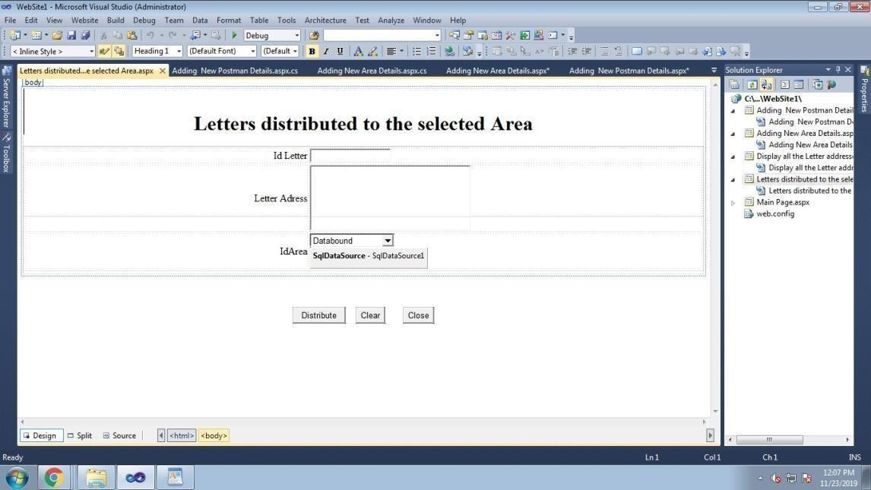

if (j >= 1)

Resp onse.Write("<script>a lert('successfuly Insretd');</script>");

else

Resp onse.Write("<script>a lert(' Insretion Faile d');</script>");

con.C lose();

}

}

usin g System; usin g

Syste m.C ollections.G en eric; usin g S ystem .Lin q;

usin g S ystem .We b; usin g

Syste m .We b.UI; usin g

Syste m.We b.UI.We bC ontrols;

usin g S ystem.D ata. S qlC lie nt;

public partial class Letters_distrib ute d_to _the _selecte d_ A re a : System .Web.UI. Pa ge

{

prote cte d void Pa ge_ Loa d (o bject sender, E ve ntA rgs e)

{

}

prote cte d void B utton1_ C lick(o bject sen der, Eve ntArgs e)

{

S qlC on n e ctio n con = ne w SqlC on ne ctio n("Data

S o urce =.\\ SQ L E X P R E S S ; Atta chD bFile name =C :\\Users\\adm inz 1\\D ocume nts\\d b_ P S M .m df;Inte grate d Se curity=True;C o nnect Time out= 30;User Insta nce =True");

con.O p e n();

int ida re a = int.Parse(Dro p Do w n L ist1. SelectedVa lu e.T o String());

strin g que ry = "insert into tbl_ Area Letters(IdL etter,Letter A d dress,IdA re a)va lues(" + Text B ox1.Te xt + ",'" + Text B ox2.Te xt + "'," + idarea + ")";

S qlC omm an d cmd = ne w SqlC o m man d(q uery, con); int j = cmd. Execute N on Q uery();

if (j >= 1)

Resp onse.Write("<script>a lert('successfuly Distribted');</script>");

else

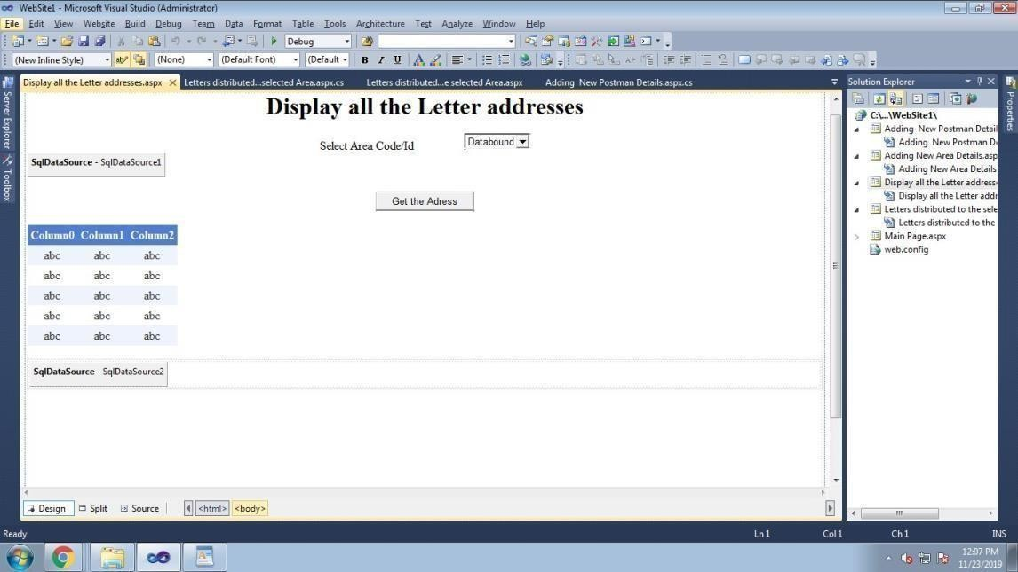

Resp onse.Write("<script>a lert(' Distrib ution Fa ile d');</script>"); con.C lose();

}

}

usin g System; usin g

Syste m.C ollections.G en eric; usin g S ystem .Lin q;

usin g S ystem .We b; usin g

Syste m .We b.UI; usin g

Syste m.We b.UI.We bC ontrols;

usin g S ystem.D ata. S qlC lie nt; usin g S ystem.D ata;

public partial class Display_all_the _Letter_a d dresses : System .Web.UI. Pa ge

{

prote cte d void Pa ge_ Loa d (o bject sender, E ve ntA rgs e)

{

}

prote cte d void B utton1_ C lick(o bject sen der, Eve ntArgs e)

{

S qlC on n e ctio n con = ne w SqlC on ne ctio n("Data

S o urce =.\\ SQ L E X P R E S S ; Atta chD bFile name =C :\\Users\\adm inz 1\\D ocume nts\\d b_ P S M .m df;Inte grate d Se curity=True;C o nnect Time out= 30;User Insta nce =True");

con.O p e n();

int ida re a = int.Parse(Dro p Do w n L ist1. SelectedVa lu e.T o String());

strin g que ry = "select Letter A d dress from tbl_ A re aLetters where IdAre a =" + idare a + ""; S qlDa ta A da pter sda = ne w SqlD ata A da pter(qu ery, con);

Data Set ds = ne w

Data Se t(); sda.Fill(ds);

Grid Vie w1. Data So urce = ds.Ta bles[0];

Grid Vie w 1.D ata Bin d(); con.C lose();

}

prote cte d void DropDo wn List 1_ Selecte dIn de xC ha nge d( object sen der, E ve nt Args e)

{

}

}